

## Topic: Accessing Downloaded Files

Some documents require the use of your computer’s applications. For example, an Excel file loaded into theSource must utilize your computer’s Excel application to open and view the document.

In these cases, theSource will display a message letting you know that a document is being downloaded by your browser. When the download is complete, click the file name at the bottom of the screen to open it directly, or click the arrow to view other options such as ‘Open’ or ‘Show in folder’.

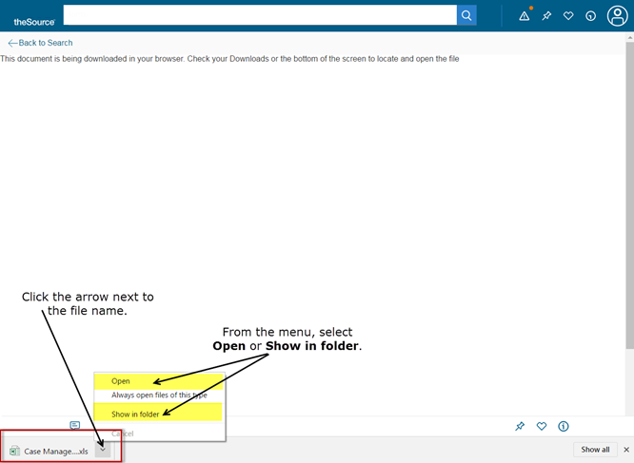

Downloading and opening files allows you to view and utilize these documents. When appropriate, you could even save a downloaded file. A good example of this would be a form you need to download, fill out, save and then email.

 Your next challenge on the quest to becoming a Certified theSource Wizard is to open [theSource - Profile Settings Reference Guide (Personal Settings)](TSRC-PROD-017625) and practice downloading and viewing the spreadsheet linked in the document (Extra credit: double-check your profile settings).

Not to Be Reproduced or Disclosed to Others without Prior Written Approval

**ELECTRONIC DATA = OFFICIAL VERSION / PAPER COPY = INFORMATIONAL ONLY**